CSA 1717-ARTIFICIAL INTELLIGENCE
LAB EXPERIMENTS
Abinaya Sri J(192524429)
AIM
To implement the Vacuum Cleaner Problem using Python to clean all dirty rooms based on the Simple Reflex Agent concept.
OBJECTIVE
- To simulate the working of a Vacuum Cleaner Agent.
- To understand how an intelligent agent senses the environment and performs actions.
ALGORITHM
Step 1: Start the program.
Step 2: Define two rooms: Room A and Room B.
Step 3: Read the status of both rooms (Clean or Dirty).
Step 4: Move the vacuum cleaner to Room A.
Step 5: Check the status of Room A.
- If Room A is Dirty, clean it.
- Otherwise, do nothing.
Step 6: Move the vacuum cleaner to Room B.
Step 7: Check the status of Room B.
- If Room B is Dirty, clean it.
- Otherwise, do nothing.
Step 8: Display the final status of both rooms.
Step 9: Stop the program.

SOURCE CODE
# Vacuum Cleaner Problem
roomA = input("Enter Room A status (Clean/Dirty): ").strip().lower()
roomB = input("Enter Room B status (Clean/Dirty): ").strip().lower()
print("\nInitial Status")
print("Room A :", roomA.capitalize())
print("Room B :", roomB.capitalize())
# Check Room A
if roomA == "dirty":
print("\nCleaning Room A...")
roomA = "clean"
else:
print("\nRoom A is already Clean")
# Check Room B
if roomB == "dirty":
print("Cleaning Room B...")
roomB = "clean"
else:
print("Room B is already Clean")
print("\nFinal Status")
print("Room A :", roomA.capitalize())
print("Room B :", roomB.capitalize())
FLOW CHART
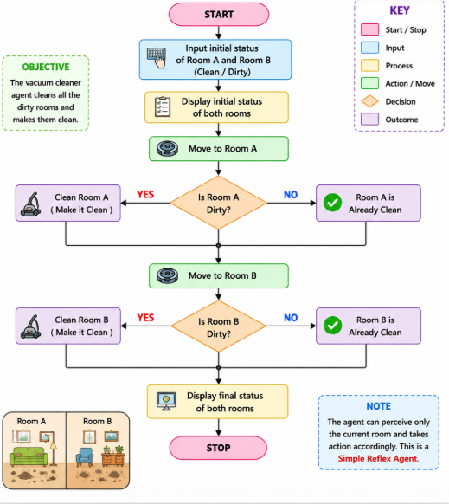
OUTPUT
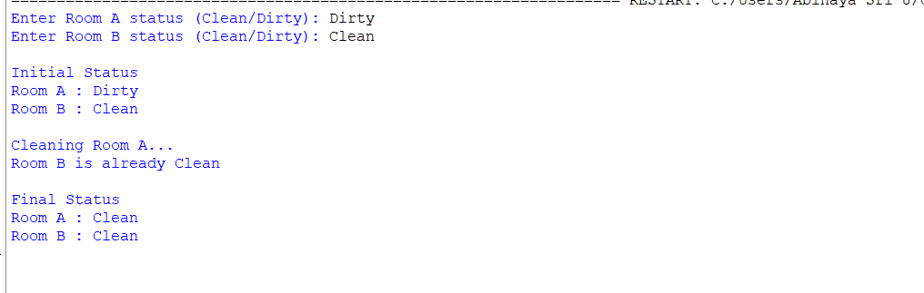
RESULT
The Vacuum Cleaner Problem was successfully implemented in Python. The vacuum cleaner agent cleaned all dirty rooms and displayed the final status with all rooms in the Clean state.

